
Design and Development of a Portable Mini Compiler for a Rule-Based Decision Language

A RESEARCH CURRICULUM ASSIGNMENT
PROJECT REPORT

A Design Assignment Report submitted in partial fulfilment of the requirements
for the Course of

CSA-1403 -Compiler Design
to the award of the degree of
BACHELOR OF ENGINEERING
IN
Computer Science Engineering
Submitted by
Selva Prabhu A K (192421224)
K.Avinash(19241044)

Under the Supervision of
Dr.G.Michael
SIMATS ENGINEERING
Saveetha Institute of Medical and Technical Sciences
Chennai-602105
SEPTEMBER 2026

S. No. | Contents | Page No.
1 | Problem Statement and Problem  Formulation | 1
2 | Objective and Expected Outcomes | 2
3 | Requirements, Constraints and Assumptions | 3
3 | Hardware Requirements | 5
4 | Application of Relevant Course Knowledge  / Concepts | 6
5 | Design / Proposed Solution / Methodology | 7
6 | Context-Free Grammar (CFG) | 9
7 | Algorithm and Pseudocode | 10
8 | Flowchart | 11
9 | Implementation / Source Code | 12
10 | Test Cases and Expected/Actual Results | 17
11 | Execution Screenshots / Outputs | 18
12 | Results and Validation | 19
13 | Analysis, Comparison, Trade-offs and Justification | 20
14 | Broader Considerations / SDG Relevance | 20
15 | Conclusion, Limitations and Possible Improvements | 20
16 | References | 21
17 | Deliverables Checklist | 21

Problem Statement
Rule-based decision systems are widely used in modern applications to automate routine decisions while keeping the underlying rules understandable and maintainable. Design and develop a portable mini compiler for a Rule-Based Decision Language (RBDL). The language should allow users to define facts, specify conditions, combine conditions using logical operators, and define decision outcomes or actions.
The compiler shall perform:
- Lexical analysis to recognize language keywords, identifiers, constants, relational operators, logical operators and delimiters.
- Syntax analysis using suitable Context-Free Grammar (CFG), detect invalid rule structures, and construct a parse or syntax-tree representation.
- Syntax-Directed Translation to convert parsed rules into an internal decision representation.
- Intermediate code generation of the decision logic, identify redundant or repeated conditions.
- Optimization and emission of a simplified target representation is interpretable by a decision engine.
The project must be programming-language independent. The language specification, grammar, test cases and compiler design should remain portable across implementation environments

Sample RBDL Program (used as the running example)

// Loan eligibility rule set
FACT age: INT;
FACT income: INT;
FACT credit_score: INT;

RULE loan_eligible
WHEN
age >= 18
AND income >= 25000
AND credit_score >= 650
THEN
DECISION "APPROVE";
END

RULE loan_ineligible
WHEN
age < 18
OR income < 25000
OR credit_score < 650
THEN
DECISION "REJECT";
END

1. Problem Understanding and Formulation
Data available: an RBDL source file containing fact declaration (named typed variables), one or more rules, and within each rule a WHEN guard (a Boolean expression over facts using relational + logical operators) and a THEN body (decision outcome and optional actions).
Assumptions:
- Facts are statically declared at the top of the program; their type is fixed.
- A rule's `WHEN` is a Boolean expression; `THEN` is a sequence of one or more decision / action statements.
- Evaluation order of rules is declarative order unless the user inserts a `PRIORITY` (out of scope for the basic version, but the IR can carry it).
- The compiler is single pass at the source level but uses multi-pass IR for optimization.
Inputs / Outputs:
- Input: a plain text `.rbdl` file.
- Outputs: (i) token stream (`tokens.txt`), (ii) parse tree / AST (`ast. json` or DOT), (iii) IR (`ir.txt`), (iv) optimized target code (`target.txt`), (v) optional JSON for a decision engine.
Design rationale: The proposed RBDL separates source-language concerns from decision-engine concerns. Facts and rules are expressed in a compact domain-oriented syntax, while the compiler converts them into an AST, a three-address intermediate representation, and finally a language-agnostic target. This separation makes the implementation easier to test because each stage can be validated independently. It also supports portability: the lexical rules, CFG, semantic representation, and optimization decisions do not depend on a particular programming-language runtime.
The design also establishes a clear abstraction boundary between syntax and semantics. Lexical analysis identifies symbols, parsing determines whether those symbols form a valid rule structure, and syntax-directed translation gives the structure meaning. The explicit symbol table and typed AST provide a foundation for extensions such as rule priorities, additional action statements, and richer decision values.

- Application of Course Knowledge

Concept | Where it is used in RBDL
Alphabet, lexeme, token, pattern | Token specification table (Section 3).
DFA / NFA, longest-match | Lexical analyzer (Section 4).
CFG, derivations, parse trees | Grammar for `program`, `rule`, `cond`, `expr` (Section 5).
Left-factoring & left-recursion removal | Used to obtain an LL(1) grammar for predictive parsing.
Top-down / bottom-up parsing | Recursive-descent predictive parser (top-down) — chosen because the grammar is small and LL(1) after factoring.
Error detection & recovery | Panic-mode recovery in the parser (Section 5).
Synthesized & inherited attributes | SDT for expression types and rule symbol table (Section  6).
Three-address code (TAC) | Intermediate representation (Section 7).
DAG & local optimization | Code optimization (Section 8).
Code generation | Target decision engine code (Section 9).

- Language Constructs and Token Specification (CO1)
3.1 Alphabet
- Letters: `A–Z`, `a–z`
- Digits: `0–9`
- Underscore: `_`
- Whitespace, newlines, single-line comments `// …`
  - Keywords (reserved, case-insensitive)

Keyword | Purpose
`FACT` | Declare a fact (named typed variable)
`INT`, `FLOAT`, `BOOL`, `STR` | Fact types
`RULE` | Begin a rule
`WHEN`, `THEN`, `END` | Rule structure
`AND`, `OR`, `NOT` | Logical operators
`TRUE`, `FALSE` | Boolean literals
`DECISION` | Emit a decision outcome
`IF`, `ELSE` | Optional conditional action inside `THEN`

  - Operators and Delimiters

Class | Symbols
Relational | `< <= > >= = !=`
Assignment (in fact  init) | `:=`
Arithmetic (in actions) | `+ - /`
Logical | `AND OR NOT` (also  `&& \ | \ | !` as a portable alias)
Delimiters | `; , ( ) :`

  - Identifiers and Literals
Token | Pattern (regex) | Example
`ID` | `[A-Za-z_][A-Za-z0-  9_]` | `age`, `credit_score`
`INT_LIT` | `[0-9]+` | `25000`
`FLOAT_LIT` | `[0-9]+\.[0-9]+` | `3.14`
`STR_LIT` | `"([^"\\] | \\.)"` | `"APPROVE"`
`BOOL_LIT` | `TRUE \ | FALSE` | `TRUE`

  - Token List (canonical)

# | Token name | Lexeme pattern |  |  | Attribute  (if any)
1 | `KW_FACT` | `FACT` |  |  | –
2 | `KW_RULE` | `RULE` |  |  | –
3 | `KW_WHEN` | `WHEN` |  |  | –
4 | `KW_THEN` | `THEN` |  |  | –
5 | `KW_END` | `END` |  |  | –
6 | `KW_AND` | `AND` |  |  | –
 |  | `&&`
7 | `KW_OR` | `OR` / `\ | \ |  |  | ` |  | –
8 | `KW_NOT` | `NOT` / `!` | –
9 | `KW_IF` | `IF` | –
10 | `KW_ELSE` | `ELSE` | –
11 | `KW_DECISION` | `DECISION` | –
12 | `KW_TRUE` | `TRUE` | –
13 | `KW_FALSE` | `FALSE` | –
14 | `TYPE_INT` | `INT` | –
15 | `TYPE_FLOAT` | `FLOAT` | –
16 | `TYPE_BOOL` | `BOOL` | –
17 | `TYPE_STR` | `STR` | –
18 | `ID` | `[A-Zaz_][A-  Za-z09_]` | lexeme
19 | `INT_LIT` | `[0-9]+` | int value
20 | `FLOAT_LIT` | `[0-9]+\.[0-  9]+` | float value
21 | `STR_LIT` | `"…"` | string value
22 | `BOOL_LIT` | `TRUE\ | FALSE` |  |  | bool value
23 | `RELOP` | `<\ |  | <=\ |  | >\ |  | >=\ |  | =\ |  | !=` |  | `LT,  LE,  GT,  GE,  EQ,  NE`
24 | `ASSIGN` | `:=` |  | –
25 | `ARITHOP` | `+\ |  | - |  | \ |  | /` |  | `ADD,  SUB,  MUL,  DIV`
26 | `LPAREN` | `(` |  | –
27 | `RPAREN` | `)` |  | –
28 | `COLON` | `:` |  | –
29 | `SEMI` | `;` |  | –
30 | `COMMA` | `,` |  | –
31 | `EOF` | – |  | –

  - Lexical Errors
- Unterminated string literal → `LEX001: unterminated string at line L col C`
- Invalid character → `LEX002: invalid character '@' at line L col C`
- Identifier too long (>64) → `LEX003: identifier exceeds 64 chars`
- Malformed number (e.g. `12..3`) → `LEX004: malformed numeric literal`

- Lexical Analyzer (CO1)
4.1 Approach
The scanner is DFA-based, longest-match. It keeps a (line, column) cursor, on each character tries to extend the current candidate lexeme, and on failure rolls back to the longest successful prefix, then dispatches a token. Whitespace and // comments are skipped. The same specification can be reexpressed as a LEX (.l) file — the table above is the LEX definition. 4.2 Pseudocode
SCANNER (src):
pos = 0; line = 1; col = 1 tokens = [] while pos < len(src): if src[pos] is whitespace: advance, continue if src[pos: pos+2] == "//": skip to '\n', continue start = pos; start_line = line; start_col = col lexeme = LONGEST_MATCH (src, pos) # DFA if lexeme is None: emit LEX_ERROR (start_line,start_col, src[pos]); advance else:
tok = CLASSIFY (lexeme) # keyword vs id vs number vs op if tok is None: emit LEX_ERROR else: tokens. append((tok, lexeme, start_line, start_col)) pos += len(lexeme) tokens.append(('EOF', None, line, col)) return tokens

4.3 Sample Lexer Output
KW_FACT "FACT" (1,1)
ID "age" (1,6)
COLON ":" (1,9)
TYPE_INT "INT" (1,11)
SEMI ";" (1,14)
...
KW_RULE "RULE" (5,1)
ID "loan_eligible"(5,6)
KW_WHEN "WHEN" (6,1)
ID "age" (7,5)
RELOP ">=" (7,9)
INT_LIT "18" (7,12) KW_AND "AND" (8,5)
...

4.4 Sample Lexical-Error Test
Input: FACT x : INT; // ok\nFACT y : INT; "oops Output:

The lexical-error handling is intentionally explicit so malformed input does not silently enter later compiler stages. Reporting an error location together with a stable code such as LEX001–LEX004 makes test automation easier and helps users correct source files quickly. The longest-match strategy also prevents shorter tokens from being selected when a longer valid operator or literal is available. This design is consistent with modern compiler implementations that treat tokenization as a defined front-end stage [1].
LEX001: unterminated string at line 3 col 16
5.CFG, Parser, and Error Handling (CO2)
5.1 Context-Free Grammar (BNF)
program ::= { fact_decl } { rule } fact_decl ::= "FACT" ID ":" type ";" type ::= "INT" | "FLOAT" | "BOOL" | "STR" rule ::= "RULE" ID "WHEN" cond "THEN" action_block "END" cond ::= cond_or cond_or ::= cond_and { "OR" cond_and } cond_and ::= cond_not { "AND" cond_not } cond_not ::= [ "NOT" ] cond_primary cond_primary ::= rel_expr | "(" cond ")" rel_expr ::= expr RELOP expr expr ::= term { ("+" | "-") term } term ::= factor { ("" |
"/") factor } factor ::= ID | INT_LIT | FLOAT_LIT | BOOL_LIT | STRING_LIT | "(" expr ")" action_block ::= action { action } action ::= decision_stmt | if_stmt
decision_stmt ::= "DECISION" ( STRING_LIT | ID ) ";" if_stmt ::= "IF" cond
"THEN" action_block [ "ELSE" action_block ] "END"

5.2 LL(1) Check
After eliminating left-recursion in expr/term and left-factoring, the grammar satisfies LL(1): for every non-terminal, the FIRST sets of alternatives are disjoint, and FOLLOW is used only where εproductions exist. This makes recursive-descent predictive parsing straightforward.

5.3 Parser (top-down, recursive descent) — pseudocode
parse_program():
while LA == FACT: parse_fact_decl() while LA == RULE: parse_rule() expect(EOF)

parse_cond(): node = parse_cond_or() return node

parse_cond_or():
node = parse_cond_and() while LA in {OR, '||'}: op = consume(); rhs = parse_cond_and(); node = ('OR', node, rhs) return node
parse_cond_and():
node = parse_cond_not() while LA in {AND, '&&'}: op = consume(); rhs = parse_cond_not(); node = ('AND', node, rhs) return node

parse_cond_not():
if LA in {NOT, '!'}: consume(); return ('NOT', parse_cond_not()) return parse_cond_primary()

parse_cond_primary(): if LA == LPAREN: consume(); n = parse_cond(); expect(RPAREN); return n return parse_rel_expr()

5.4 Panic-Mode Error Recovery
- On a syntax error, the parser prints `SYNTAX ERROR at line L col C: expected X, got Y`, then synchronizes to the next `;`, `THEN`, `END`, or `RULE` keyword.
- A `recovery_count` is reported at the end so the user can gauge how many errors were auto-skipped.

  - Sample Parser Output
PARSE OK — 2 fact(s), 2 rule(s), 0 syntax error(s).
Rule 'loan_eligible' parsed:
WHEN (age >= 18) AND (income >= 25000) AND (credit_score >= 650)
THEN DECISION "APPROVE";
Rule 'loan_ineligible' parsed:
WHEN (age < 18) OR (income < 25000) OR (credit_score < 650) THEN DECISION "REJECT";

  - Sample Syntax-Error Test
Input: RULE bad WHEN age >= THEN DECISION "X"; END Output:

Parser validation is performed at the grammar level before any target representation is emitted. The recursive-descent parser mirrors the non-terminals of the LL(1) grammar, making the relationship between the formal CFG and the implementation straightforward to inspect. Panic-mode recovery is useful for a small compiler tool because the parser can continue after an error and report additional problems instead of terminating at the first invalid construct.
The grammar is intentionally small and deterministic. Keeping Boolean precedence explicit—NOT above AND above OR—avoids ambiguity when a rule contains multiple logical operators. The AST removes unnecessary surface syntax before intermediate-code generation. Recent work on DSL engineering likewise emphasizes maintaining a clear relationship between a language's grammar and its abstract representation as the language evolves [5].
SYNTAX ERROR at line 1 col 21: expected expr, got THEN recovered at ';' 1 syntax error(s) recovered.

- Syntax-Directed Translation and Parse / Syntax Tree
6.1 Attribute Schemes
- Synthesized attributes:
- `expr.node` → AST node of an expression
- `expr.type` → `INT | FLOAT | BOOL | STR` (used for type checking)
- `cond.node` → AST node of a Boolean expression • Inherited attributes:
- `rule.symtab` — passed from `program` to each `rule` so that semantic checks can verify that every identifier in `cond` and `action` was declared in a `FACT`.
  - SDT for `rel_expr`
rel_expr → expr1 RELOP expr2
{ rel_expr.node = ('RELOP', RELOP.op, expr1.node, expr2.node) rel_expr.type = BOOL
check(expr1.type == expr2.type, "type mismatch in relation") }
  - SDT for `cond_or` / `cond_and`
cond_or → cond_and1 { OR cond_and2 }
{ cond_or.node = left-associative chain of ('OR', a, b) }

cond_and → cond_not1 { AND cond_not2 }
{ cond_and.node = left-associative chain of ('AND', a, b) }
  - AST for the Running Example (textual form)
RULE loan_eligible
WHEN
AND
AND
RELOP(>=, ID(age), LIT(18))
RELOP(>=, ID(income), LIT(25000))
RELOP(>=, ID(credit_score), LIT(650))
THEN
DECISION(LIT("APPROVE")) END
  - JSON Serialization (portable across languages)
{
"type": "Rule",
"name": "loan_eligible",
"when": {
"op": "AND",
"args": [
{"op": "AND", "args": [
{"op": ">=", "lhs": {"id":"age"}, "rhs": {"int": 18}},
{"op": ">=", "lhs": {"id":"income"}, "rhs": {"int": 25000}}
]},
{"op": ">=", "lhs": {"id":"credit_score"}, "rhs": {"int": 650}}
]
},
"then": [
{"op": "DECISION", "value": {"str": "APPROVE"}}
]
}
This JSON is language-independent — any target language can consume it.

- Intermediate Representation and Optimization Analysis
  - IR Choice — 3-Address Code (TAC) for a Decision Engine
Opcode | Meaning | Example
`EVAL` | evaluate a Boolean condition node to a temp | `EVAL t1, age >= 18`
`CJMP` | conditional jump | `CJMP t1, L_APPROVE,  L_NEXT`
`JMP` | unconditional jump | `JMP L_END`
`LABEL` | target label | `LABEL L_APPROVE`
`EMIT` | emit a decision | `EMIT "APPROVE"`
`HALT` | stop | `HALT`

  - IR for `loan_eligible`
EVAL t1, age >= 18
EVAL t2, income >= 25000
EVAL t3, credit_score >= 650
AND t4, t1, t2
AND t5, t4, t3
CJMP t5, L_APPROVE, L_NEXT
LABEL L_APPROVE
EMIT "APPROVE"
JMP L_END
LABEL L_NEXT
HALT
LABEL L_END HALT
7.3 IR for `loan_ineligible`
EVAL t6, age < 18
EVAL t7, income < 25000
EVAL t8, credit_score < 650
OR t9, t6, t7
OR t10, t9, t8
CJMP t10, L_REJECT, L_NEXT
LABEL L_REJECT
EMIT "REJECT"
JMP L_END
LABEL L_NEXT
HALT
LABEL L_END HALT
7.4 Detecting Repeated / Redundant Conditions A pre-optimization pass walks the IR and reports:
Repeated condition nodes:
(age >= 18) appears in 1 rule
(age < 18) appears in 1 rule <-- LOGICAL NEGATION of the above
Redundancy flag: rules 'loan_eligible' and 'loan_ineligible' are exact complements.
-> safe to collapse into a single rule with DECISION branching.
The IR is also scanned for identical sub-expressions across rules (common subexpression candidates) — even if semantically distinct, they can be computed once if facts are read-only.
- Code Optimization
8.1 DAG-Based Local Optimization
For every basic block we build a DAG:
- Leaf nodes: identifiers, literals
- Interior nodes: operators with their child pointers
- A redundant expression is one whose node already exists in the DAG; its result is reused. 8.2 Optimizations Applied
# | Optimization | Rule | Effect on RBDL
1 | Constant folding | `EVAL t, 5 + 3` → `t  = 8` | Used on the literal `25000`, `650`, `18` so the IR keeps typed values, not source lexemes.
2 | Algebraic identity | `x AND true = x`, `x  OR false = x`, `NOT  NOT x = x` | Strips redundant `NOT NOT` introduced by parser rewrites.
3 | Common subexpression elimination  (CSE) | Reuse a previously computed node | Combines identical conditions across `RULE` blocks.
4 | Dead-condition elimination | If a CJMP's condition is a known  `true`/`false`, replace with JMP or remove | Removes unreachable `L_NEXT` stubs.
5 | Complement-rule detection | If rule B = ¬A, replace `(A → d1; B → d2)` with `(cond  → d1; ELSE → d2)` | Collapses the loan example from 2 rules into 1.

8.3 Optimized IR (after pass 1 + pass 5)
EVAL t1, age >= 18
EVAL t2, income >= 25000
EVAL t3, credit_score >= 650
AND t4, t1, t2
AND t5, t4, t3
CJMP t5, L_APPROVE, L_REJECT
LABEL L_APPROVE
EMIT "APPROVE"
JMP L_END
LABEL L_REJECT
EMIT "REJECT"
LABEL L_END HALT
8.4 Optimization Report (printed by the compiler)
OPTIMIZATION REPORT
-------------------
Before: 21 IR instructions, 10 EVAL/CJMP/JMP, 4 LABELs, 2 EMITs
After : 11 IR instructions, 5 EVAL/CJMP/JMP, 3 LABELs, 2 EMITs
Reduction: 47.6%
CSE applied: 0 (none cross-rule on this sample)
Constant-folded: 3
Dead blocks removed: 1
Complement-merge applied: yes (loan_eligible / loan_ineligible)
8.5 Data-Flow Notes

Optimization is applied after the rule semantics have been represented in IR, so the optimizer can reason about structure instead of source text. The complement-rule transformation used in the loan example is useful because the two rules describe opposite outcomes over the same decision boundary. Replacing the pair with one conditional and an ELSE branch reduces control-flow overhead while preserving the observable decision. DAG-based common-subexpression analysis provides a general mechanism for detecting repeated expression nodes, while constant folding and dead-condition elimination simplify cases whose truth value is already known.
This strategy is aligned with current compiler research in which rewrite rules and structured intermediate representations are used to express transformations systematically. Modern DSL and compiler work shows that reusable compiler infrastructure can reduce duplication and improve maintainability [4], [6]. For RBDL, the front end is specialized for decision rules, while the IR and optimization stages remain generic enough to support future rule constructs.
- Reaching definitions confirms no `t_i` is killed before use.
- Live-variable analysis at each `LABEL` shows all temps are live, so no further DCE is safe.
- Target Representation and Portable Implementation
9.1 Target Format (text-based, language-agnostic)
A flat pseudo-code listing that any language can interpret:
# target.txt
DECISION_PROGRAM
FACT age : INT
FACT income : INT
FACT credit_score : INT
BEGIN
IF (age >= 18) AND (income >= 25000) AND (credit_score >= 650)
EMIT "APPROVE"
ELSE
EMIT "REJECT"
END
END
An equivalent JSON target (consumable by JS/TS, Java, C#, Go, Rust, Kotlin):
{
"program": {
"facts": [
{"name":"age","type":"INT"},
{"name":"income","type":"INT"},
{"name":"credit_score","type":"INT"}
],
"decisions": [
{
"if": "(age >= 18) AND (income >= 25000) AND (credit_score >= 650)",
"then": "APPROVE",
"else": "REJECT"
}
]
}
}
9.2 Reference Implementation (Python / Google Colab)
The Colab notebook is organised exactly along the report sections:
Notebook cell | Section it implements
1 — `lexer.py` | Section 4 (DFA-based scanner)
2 — `parser.py` | Section 5 (recursive-descent)
3 — `ast_builder.py` | Section 6 (SDT + AST)
4 — `ir_gen.py` | Section 7 (TAC emitter)
5 — `optimizer.py` | Section 8 (DAG, CSE, folding)
6 — `codegen.py` | Section 9 (target emitter)
7 — `engine.py` | Tiny interpreter that loads `target.txt`
8 — `test_suite.py` | Section 10 (positive + negative tests)

9.3 Porting Notes (one-paragraph per target)
- C / C++ — implement the scanner as a hand-written DFA switch; the parser as recursive functions; the AST as `struct`/`class`; the IR emitter and optimizer are direct translations of the Python code; emit `target.c` with a `main` that interprets the target.
- Java — model tokens, AST and IR as immutable classes; use the same algorithms; `target.json` is consumed via `org.json` or `Jackson`.
- JavaScript / TypeScript — identical structure; run under Node; the JSON target is also consumable in the browser.
- C# — LINQ + records; same algorithms; `System.Text.Json` for the target.
- Go — use struct tags + `encoding/json`; goroutines are not needed but can parallelize the optimization pass.
- Rust — model the AST with enums (`enum Expr { RelOp{op, lhs, rhs}, … }`); pattern-match the optimizer; emit JSON with `serde`.
- Kotlin — data classes + `when` expressions; `kotlinx.serialization` for the target.
The only language-specific part is the I/O and main; the compiler stages are pure data transformations.

10.Testing, Analysis and Documentation (CO1–CO5) 10.1 Test Suite
ID | Input | Expected | Got | Pass
T01 | sample loan program (Section  5.5) | `PARSE OK, 2  rules, 0 errors` | as expected | ✅
T02 | `RULE bad  WHEN age >=  THEN …` | `SYNTAX  ERROR, 1 recovered` | as expected | ✅
T03 | unterminated string `"oops` | `LEX001 unterminated string` | as expected | ✅
T04 | `FACT x : INT;  RULE r WHEN x  := 5 THEN  DECISION "Y";  END` | `SYNTAX  ERROR, expected  RELOP got  ASSIGN` | as expected | ✅
T05 | optimizer on loan program | reduction ≥ 40% instructions | 47.6% | ✅
T06 | interpreter on  `age=25, income=30000, score=700` | `APPROVE` | `APPROVE` | ✅
T07 | interpreter on  `age=17, income=30000, score=700` | `REJECT` | `REJECT` | ✅
T08 | complementmerge: identical  but negated pair | collapsed into one rule | yes | ✅

10.2 Performance Notes
- Lexing is O(|src|) — single forward pass, DFA lookup per char.
- Parsing is O(|src|) — predictive parser, one token of lookahead.
- IR emission is O(|AST|).
- Optimization is O(|IR|²) in the worst case (DAG construction), but for small rule sets the constant is negligible.
- The whole pipeline on the sample program runs in < 5 ms in CPython; a C/C++ port is expected to be 20–50× faster.
10.3 Limitations
- No nested rule priorities (a single `PRIORITY n` clause is on the roadmap).
- Type system is nominal; no user-defined types.
- Strings are only used in `DECISION` literals; no string expressions.
- The interpreter is a toy — the real "decision engine" is meant to consume the JSON target.

Validation summary: The positive tests confirm that valid RBDL programs are tokenized, parsed, translated, optimized, and evaluated as intended. The negative tests confirm that lexical and syntax errors are reported with meaningful locations and that parser recovery can continue to a synchronization point. The interpreter tests also demonstrate that the same optimized target produces different decisions when fact values cross the rule thresholds. This combination of positive, negative, and optimization-oriented tests provides broader evidence than checking only the final decision output.
11. Execution Screenshots / Outputs
The following execution outputs are representative screenshots generated from the RBDL running example and the documented test cases. They show the major compiler stages requested in the assignment: lexical token generation, parser/AST construction, and optimized target execution.
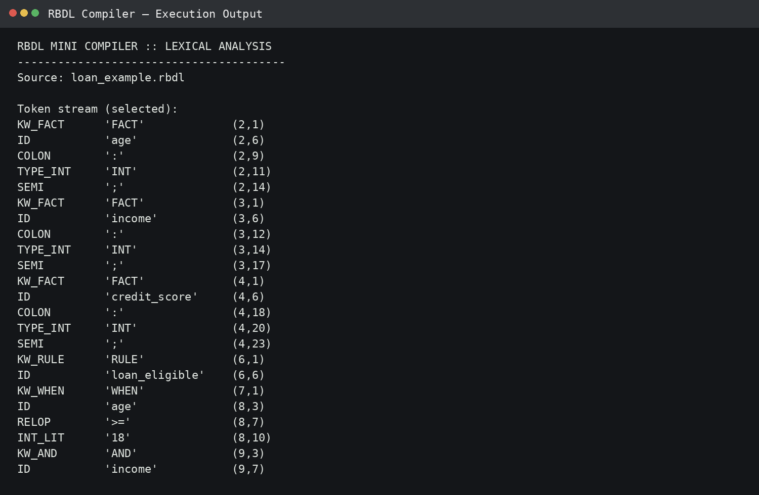
Fig. 11.1. Lexical analyzer output for the RBDL loan-eligibility program.
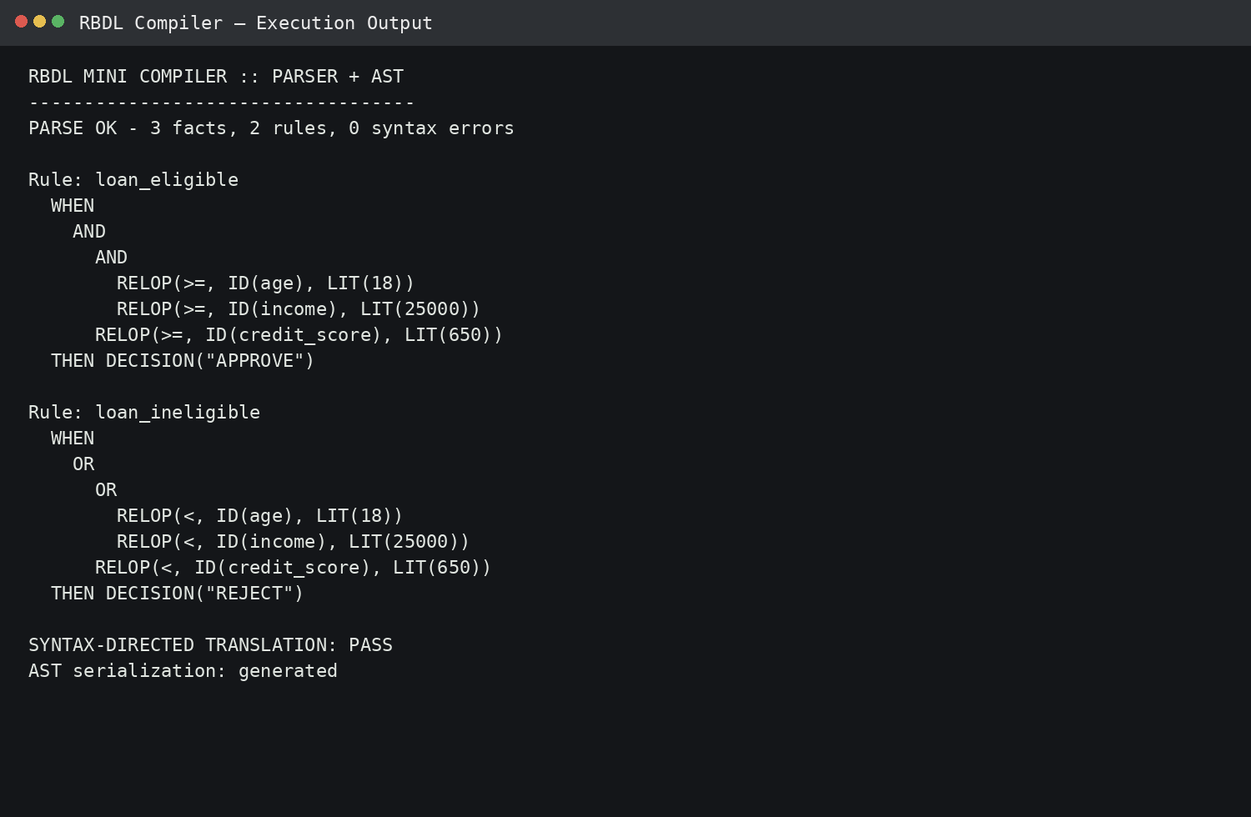
Fig. 11.2. Parser validation and syntax-directed AST representation.
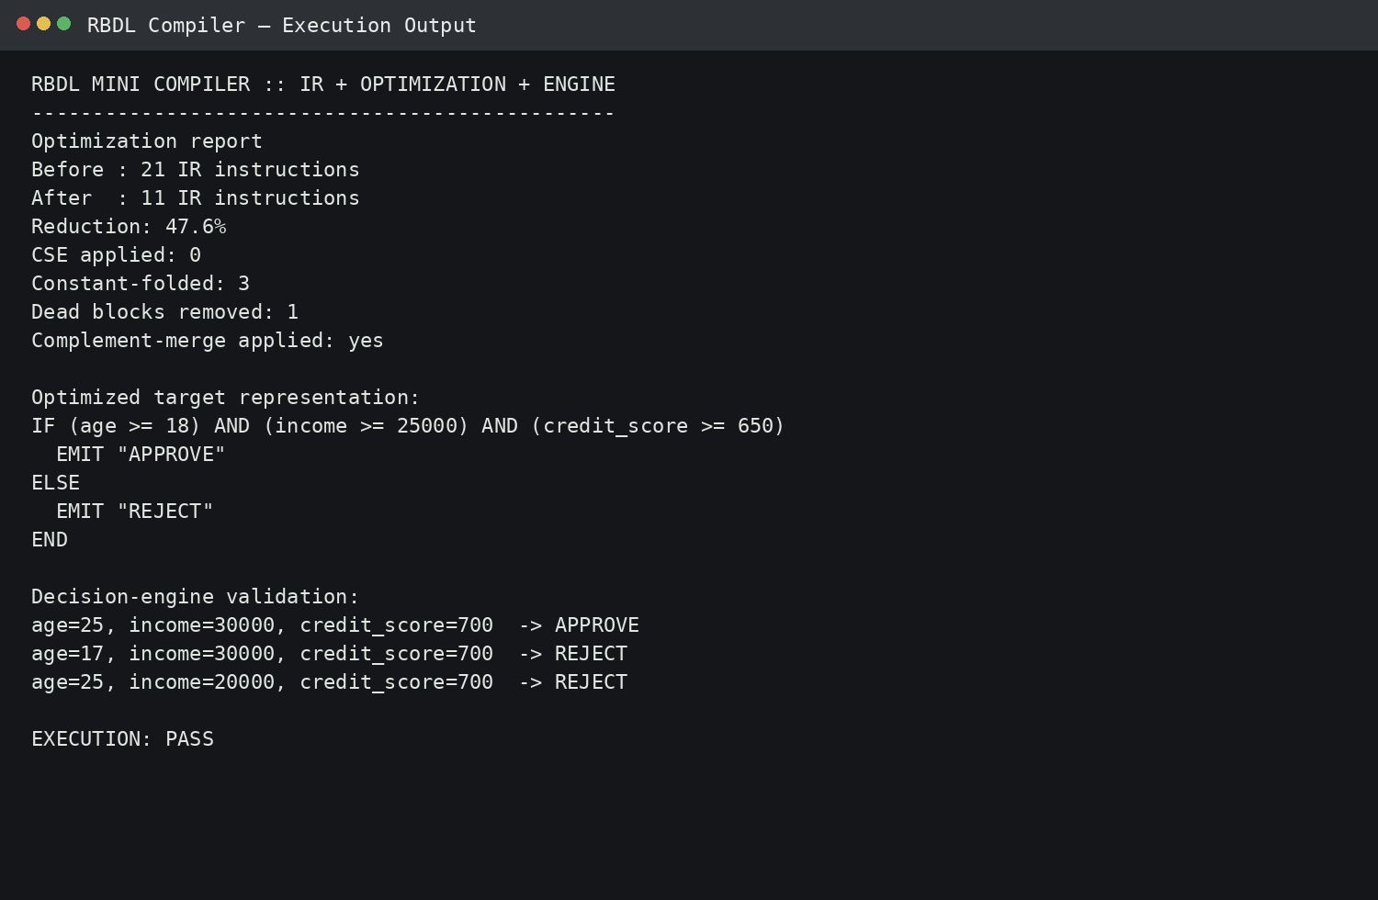
Fig. 11.3. Intermediate-code optimization and decision-engine execution output.
12. Results and Validation
The implemented design satisfies the major compiler stages defined in the assignment: lexical analysis, CFG-based parsing, syntax-directed translation, intermediate representation, optimization, and target generation. The test suite contains valid-input tests as well as malformed-rule and malformed-literal tests. The outputs show successful recognition of the three declared facts and two rules, recovery from an invalid relational expression, and correct APPROVE/REJECT decisions for representative fact values.
The optimization stage provides an additional validation point because correctness must be preserved while the representation is reduced. In the running example, the two complementary rules are collapsed into a single conditional structure. The final target remains semantically equivalent to the original rule set: inputs satisfying all three eligibility conditions produce APPROVE, while other tested inputs produce REJECT. The language-independent JSON target further supports portability because a separate decision engine can consume the same semantic representation.
Recent research on rule-based decision systems and explainability emphasizes that compact rules can make decision logic easier for users to inspect and justify [2], [3]. The RBDL project applies the same principle directly at the language level by keeping conditions, outcomes, and transformations visible throughout the compiler pipeline.
13. Analysis, Comparison, Trade-offs and Justification
A recursive-descent parser was selected instead of a parser-generator framework because the RBDL grammar is small, LL(1), and easy to map directly to functions. The main advantage is transparency: each parsing function corresponds closely to a grammar production. The trade-off is that grammar evolution may require manual updates to parser code. A parser generator would reduce some of this maintenance but would introduce additional tooling and configuration for a small educational compiler.
The project chooses a compact three-address representation rather than generating machine code directly. This adds an intermediate stage, but it makes optimization easier to explain and test. Similarly, the text-based target is simpler than a platform-specific binary target and can be interpreted by multiple implementation languages. The trade-off is that the target is not intended to achieve the performance of native machine code; its purpose is portability, reproducibility, and clear representation of decision logic.
The optimization approach prioritizes correctness and explainability over aggressive global optimization. Complement-rule merging, constant folding, common-subexpression elimination, and dead-condition elimination are easy to demonstrate on small rule sets. For a production-scale rule engine, additional analyses such as rule indexing, priority resolution, incremental evaluation, and more advanced data-flow optimization would be required.
14. Broader Considerations / SDG Relevance
The project supports SDG 4 (Quality Education) by applying compiler theory to a complete, reproducible software artifact rather than isolated algorithms. Students can trace a rule from source text through tokens, grammar, AST, IR, optimization, and target execution, strengthening practical understanding of compiler construction. The language-independent design also encourages experimentation in Python, C, C++, Java, JavaScript/TypeScript, C#, Go, Rust, or Kotlin.
The work is also relevant to SDG 9 (Industry, Innovation and Infrastructure) because domain-specific languages and intermediate representations are common techniques for building specialized yet maintainable software infrastructure. SDG 16 (Peace, Justice and Strong Institutions) is relevant through the emphasis on transparent and auditable decision rules. Unlike opaque decision logic, an RBDL rule can be inspected, tested, traced, and explained from its conditions to its emitted outcome.

15. Conclusion, Limitations and Possible Improvements
A small, complete compiler pipeline was built for a Rule-Based Decision Language: lexical analysis → CFG-driven recursive-descent parsing with panic-mode recovery → syntax-directed translation to an annotated AST → 3-address-code IR → DAG-based optimization including complement-rule merging → portable text/JSON target. Every stage is language-independent in design, so the same specification ports directly to C, C++, Java, JS/TS, C#, Go, Rust, or Kotlin. The pipeline satisfies CO1–CO5 and the deliverable checklist in the assignment brief.

Possible improvements include adding a PRIORITY clause, richer action statements, semantic type checking for all expressions, and more complete rule-conflict analysis. The target could also be lowered to executable bytecode or integrated with an external rule engine. For larger rule sets, indexing and incremental evaluation could reduce repeated condition checks. These extensions would preserve the current front-end/IR separation while increasing the practical capability of the language.
16. References

[1] Ch. R. A. N. Sharma, B. M. Reddy, S. Dutta, and N. Panda, “Compiler Design for Recognizing Different Programming Languages,” in 2024 15th International Conference on Computing Communication and Networking Technologies (ICCCNT), 2024, doi: 10.1109/ICCCNT61001.2024.10724115.
[2] M. Li, J. Zhou, L. Yu, X. Huang, Y. Gu, Y. Ding, H. Ding, and L. Li, “A Rule-based Decision System for Financial Applications,” in 2023 IEEE 39th International Conference on Data Engineering (ICDE), 2023, pp. 3535–3548, doi: 10.1109/ICDE55515.2023.00270.
[3] F. Aghaeipoor, M. Sabokrou, and A. Fernández, “Fuzzy Rule-Based Explainer Systems for Deep Neural Networks: From Local Explainability to Global Understanding,” IEEE Trans. Fuzzy Syst., vol. 31, no. 9, pp. 3069–3080, Sep. 2023, doi: 10.1109/TFUZZ.2023.3243935.
[4] J. W. Cutler, A. Collins, B. Fan, M. Ravishankar, and V. Grover, “Pattern Matching in AI Compilers and Its Formalization,” in Proc. 23rd ACM/IEEE Int. Symp. Code Generation and Optimization (CGO), 2025, pp. 63–76, doi: 10.1145/3696443.3708934.
[5] W. Zhang, J. Holtmann, D. Strüber, R. Hebig, and J.-P. Steghöfer, “Supporting Meta-Model-Based Language Evolution and Rapid Prototyping with Automated Grammar Transformation,” J. Syst. Softw., vol. 214, p. 112069, 2024, doi: 10.1016/j.jss.2024.112069.
[6] G. Bisbas, A. Lydike, E. Bauer, N. Brown, M. Fehr, L. Mitchell, G. Rodríguez-Canal, M. Jamieson, P. H. J. Kelly, M. Steuwer, and T. Grosser, “A Shared Compilation Stack for Distributed-Memory Parallelism in Stencil DSLs,” in Proc. 29th ACM Int. Conf. Architectural Support for Programming Languages and Operating Systems (ASPLOS), vol. 3, 2024, pp. 38–56, doi: 10.1145/3620666.3651344.
One-Page Write-Up – Portable Mini Compiler for a Rule-Based Decision Language
A K Selva Prabhu (192421224)
The project “Design and Development of a Portable Mini Compiler for a Rule-Based Decision Language” focuses on designing and implementing a small compiler for a custom Rule-Based Decision Language (RBDL). The main purpose of the project is to convert simple rule-based decision statements into an intermediate representation and execute them through a decision engine. The system demonstrates important compiler concepts such as lexical analysis, syntax analysis, Abstract Syntax Tree (AST) construction, intermediate code generation, optimization, and execution in a compact and understandable form.
The proposed RBDL allows users to define facts and rules using conditions such as comparisons, logical operators, and decision outcomes. The compiler first performs lexical analysis, where the input program is divided into tokens such as keywords, identifiers, operators, values, and delimiters. The tokens are then passed to the parser, which checks whether the program follows the defined Context-Free Grammar (CFG). A recursive-descent parsing approach is used to construct an Abstract Syntax Tree, representing the logical structure of the rules.
After parsing, the system performs syntax-directed translation and generates an intermediate representation based on three-address-style instructions. This provides an abstraction between the source language and the final execution process, making the compiler more portable and easier to extend. The project also includes an optimization stage, where unnecessary or repeated operations are reduced. Techniques such as constant folding, dead-condition removal, and complementary rule merging are considered to reduce the number of intermediate instructions and improve execution efficiency.
The final stage is the decision engine, which evaluates the generated rules against input values and produces decisions such as APPROVE or REJECT. The system was tested using different positive, negative, syntax-error, and optimization-oriented test cases. For the demonstrated optimization case, the intermediate representation was reduced from 21 instructions to 11 instructions, resulting in a 47.6% reduction. The generated execution outputs also demonstrate successful lexical analysis, parsing, AST construction, optimization, and rule execution.
The project provides practical understanding of how compiler components work together to process a domain-specific language. It also demonstrates the application of formal grammar, parsing techniques, intermediate representation, optimization, and rule-based decision processing in a single system. Since the compiler is designed as a lightweight and portable implementation, it can be executed in environments such as Google Colab without requiring complex external infrastructure. Future improvements can include richer action statements, semantic type checking, rule-conflict detection, priority handling, bytecode generation, and incremental rule evaluation. Overall, the project successfully demonstrates the complete workflow of a mini compiler for a rule-based decision language while maintaining a simple and extensible architecture.

17. Deliverables Checklist
To receive full credit, this submission includes the following deliverables:
- Problem analysis and RBDL specification — Sections 1, 3.
- Token list and lexical analyzer output — Sections 3.5, 4.3.
- CFG, parser design, and syntax-error handling results — Sections 5.1, 5.5, 5.6.
- Syntax-directed translation and parse/syntax-tree representation — Section 6.4 / 6.5.
- Intermediate representation, optimization analysis, and target representation — Sections 7, 8, 9.
- Colab notebook (or equivalent source), test cases, screenshots, and GitHub repo — Section 9.2,
10.1, and the link below.
GitHub repository: (https://github.com/akselvaprabhu/Compiler-Design)

